Nithiyashree V K | Kumaraguru College of Technology

**Amazon Prime Analysis**

# Dataset

**8807** Rows and **12** Columns

Time Period : **1925 - 2021**

Visualization

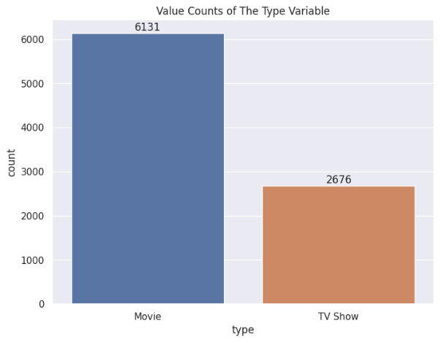

Inference & Implications

* Amazon Prime Video uploads more **movie** shows than TV shows
* Most uploaded shows on amazon prime video are from the **US**
* Majority of the Movies and TV Shows are released in-between **2015 – 2020**.
* Amazon prime video has the most uploads in the **drama, international movie** category
* Shows uploaded on amazon prime videos are mostly directed by **Rajiv Chilaka**
* The most uploaded show rating on amazon prime video is **TV-MA (Mature Audience)**